|  |  |
| --- | --- |
| UFCFS4-30-3 Creative Technologies Project Proposal Document | |
| Student Name: | Michael Ratcliffe |
| Student Number: | 16024897 |
| Project Title: | Using gamification to encourage healthy lifestyle choices in students and young adults. |

# Description

It is well established that some of the best ways to alleviate the symptoms of mental health disorders are healthy lifestyle choices such as physical exercise, a good diet (Velten, J. 2018) and good sleeping habits (Thomée, S. 2011). Young adults and students in the UK have been said to be in the midst of a mental health crisis – with 1 in 6 young adults experience symptoms of common mental health disorders and less than 1 in 3 young adults getting access to NHS care and support (NHS Digital 2016).

This project will aim to produce an app that teaches and promotes healthy lifestyles for students and young adult. The app could monitor key contributors to a healthy lifestyle, such as exercise, sleep patterns and food intake. In order to make it fun and engaging as well as standout from other apps, it could feature a virtual avatar to give advice as well as motivate the user to maintain habits.

A virtual avatar is a common feature in games but would set the app apart from other ‘traditional’ fitness apps. An avatar is often used as a device for a player to associate with or something to roleplay as. In order to stay motivated and engaged, users will receive reminders and notifications from the avatar. As well as this, by maintaining habits and completing tasks, users will receive virtual items, possibly in the form of a virtual currency, to customise the app and avatar.

Success of the project could be measured using several methods, including user testing and iteration from any feedback received. This will allow for iteration on the concepts that are designed and implemented but also help to find any bugs to make the final experience enjoyable and engaging.

**Deliverables:**

* An application – executable file or similar and a demo build on a device
* Application design documents
* Results of any testing conducted

# Research and background

As a student at UWE, I’m proud of the work the university does to raise awareness of student mental health issues and the facilities that our available to the student body – such as the Mental Health Champion scheme.

As part of my initial research, I’ve learnt that one of the best ways to maintain good mental health, especially in young adults, is to maintain a healthy and active lifestyle (Velten, J. 2016). As mentioned, important parts of this lifestyle include: exercise diet and sleep.

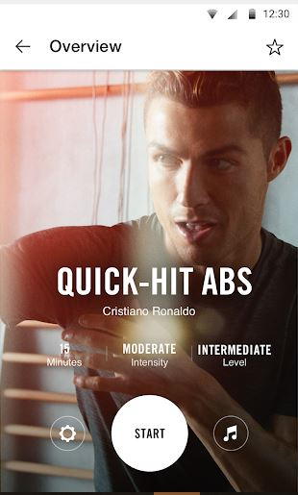Many popular health and fitness apps such as Nike Training Club, although the content may be sound, appear drab in terms of aesthetic; which may be disengaging to some users. As well as this, many features celebrity endorsements (fig 1) which can damage the self-esteem and mental health of young people by setting unrealistic standards (Parveen, N. 2018).

Research shows that through gamification, users can be motivated to use apps through elements such as virtual avatars (Sailor, M. 2017).

One app that uses a virtual avatar and a bright colour scheme to gain and maintain a large user base is the language learning app, Duolingo. The app uses a green owl, named Duo, as a mascot to motivate users to study their language daily. As well as this, the app has simple shapes and images (fig 2); as well as a bright colour scheme which can trigger certain emotional responses in its users (O’ Connor, Z, 2011) and possibly motivate users to come back.

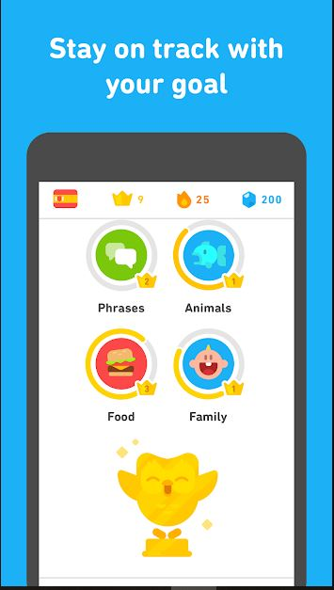One other motivational factor that contributes to the popularity of Duolingo is the release of dopamine during use of the app. Many studies show that video game users receive dopamine while playing games and crave that small hit (Green, C. and Bavelier, D. 2004)

Figure 1- Screenshot from Nike Training Club app with celebrity endorsement

Based on this research, in order to make a fun and engaging app that promotes a healthy lifestyle, this project will encourage users to eat well, exercise properly and maintain a good sleep routine in order to help combat symptoms of mental illness and boost general wellbeing. This will be helped in part by the use of a customisable, virtual avatar as this is proven to boost usage.

Figure 2 – Image from Duolingo Google Play Store page featuring ‘Duo’ mascot as well as simple, colourful images

# Objectives

### Project objectives

* Promote healthy lifestyles to combat mental health issues amongst students and young adults
* Create a fun and engaging app

### Research objectives

* Investigate student and young adult lifestyles and attitudes towards health and fitness in order to set realistic targets for users
* Research healthy lifestyles and fitness regimes to base user tasks on
* Investigate similar apps and methods for motivation and user retention
* Understand how users respond to gamified delivery methods compared to more ‘traditional’ fitness apps

### Learning Objectives

* A solid understanding of app development
* The use of ‘serious’ game design for real world applications
* What factors motivate young adults and students to stay healthy
* An insight into user motivation and user retention in lifestyle apps
* A good understanding of user testing for applications

**Methods, techniques, tools and processes**

In terms of project management – a Gantt chart will be produced based on the monthly project plan. This will allow more specific planning and can adapt the schedule if any unexpected delays arise.

The app will be produced using an Agile development cycle, as the app may need to be redesigned and assessed after each phase of testing and Agile allows for this.

For version control, a private Github repository will be used to mitigate the risk of losing data. This will also help maintain structure and keep track of version number.

More research is needed to determine what platform to build the app for and which language is best to write the app in.

For the testing, once suitable participants are found, I will collect data and results online through the app, possibly using SQL or similar, and via questionnaires.

# Risks and issues

|  |  |  |
| --- | --- | --- |
| Risk | Mitigation | Contingency |
| Poor/ineffectual feedback | Look for clear structured targets | Base app on other, similar research. |
| Inability to collect user data through the app (online) | Research data collection for apps | Collect user data through questionnaires or interview |
| Loss of device leading to inability to test my own app | Multiple devices, device tracking software | Emulators to test app |

# Specialist resources and support required

Software to allow app development (e.g. Android studio) on university computers would be helpful but not necessary. Similarly, some emulation software would be good to allow me to work on the app at university instead of solely on my own device.

# Sources and references

NHS (2016) Adult Psychiatric Morbidity Survey: Survery of Mental Health and Wellbeing [Online] Available from

<https://digital.nhs.uk/data-and-information/publications/statistical/adult-psychiatric-morbidity-survey/adult-psychiatric-morbidity-survey-survey-of-mental-health-and-wellbeing-england-2014>

Velten, J (2018) Lifestyle choices and mental health: a longitudinal survey with German and Chinese Student *BMC Public Health [*online]. 18, 632 [Accessed 06 October 2019]

Thomée, S. (2011) Mobile phone use and stress, sleep disturbances, and symptoms of depression among young adults – a prospective cohort study. *BMC Public Health* [online] 11, 66 [Accessed 06 October 2019]

Parveen, N (2011) Social media and celebrity culture ‘harming young people’ *The Guardian* [Online] Published 23 July 2018 [Accessed 08 October 2019]

Sailor, M and Hense, J U (2017) How Gamification Motivates: An Experimental Study of the Effects of Specific Game Design Elements on Psychological Need Satisfaction. Computers in Human Behaviour [online]. 69, pp. 371-380. [Accessed 07 October 2019].

O'Connor, Z. (2011) Colour psychology and colour therapy: Caveat emptor. *Color Research and Application* [online]. 36 (3), pp.229-234.

Green, C. and Bavelier, D. (2004) The Cognitive Neuroscience of Video Games. In: Messaris, P. and Humphreys, L., eds. (2004) Digital Media: Transformations in Human Communication. Blackwell Publishing Inc,

Nike Training Club image – Nike, Inc. (2019)

Duolingo image – Duolingo Inc (2019)

# Monthly project plan

|  |  |  |
| --- | --- | --- |
| October | Final proposal to be submitted by 10/10/2019  Begin research into health and fitness  Research similar apps and user retention | 4 days  7 days  7 days |
| November | Begin app design  Install relevant software  Begin implementation  Pre-alpha testing | 12 days  2 days  14 days  3 days |
| December | Write up results of testing and evaluate  Redesign based on pre-alpha build  Patch/bug fix pre-alpha build  Sprint to alpha build  Alpha testing | 2 days  3 days  4 days  10 days  5 days |
| January | Write up results of testing and evaluate  Redesign based on results  Patch/bug fix  Implement towards beta build | 3 days  3 days  5 days  14 days |
| February | Find users for testing  Beta Test  Write up beta results and evaluate  Patch/bug fix  Implement final features based on beta results | 4 days  10 days  4 days  (Continuous until April)  12 days |
| March | Optimise app and patch app | 30 days |
| April | Write up report  Package submission  Hand-in 23/04/2020 | 20 days  2 days |



Faculty of Environment & Technology

Faculty Research Ethics Committee (FREC)

**Ethical Review Checklist for Undergraduate and Postgraduate Modules**

*Please provide project details and complete the checklist below.*

**Project Details:**

|  |  |
| --- | --- |
| **Module name** | **Creative Technologies Project** |
| **Module code** | **UFCFS4-30-3** |
| **Module leader** | Michaela Palmer |
| **Project Supervisor** | Lloyd Savickas |
| **Proposed project title** | Using gamification to encourage healthy lifestyle choices in students and young adults. |

**Applicant Details:**

|  |  |
| --- | --- |
| **Name of Student** | Michael Ratcliffe |
| **Student Number** | 16024897 |
| **Student’s email address** | michael2.ratcliffe@live.uwe.ac.uk |

| **CHECKLIST QUESTIONS** | | **Yes/No** | **Explanation** |
| --- | --- | --- | --- |
|  | Does the proposed project involve **human tissue,** **human participants, animals, environmental damage, or the NHS.** | No | *If the answer to this is ‘No’ then no further checks in the list need to be considered.* |
|  | Will participants be clearly asked to give consent to take part in the research and informed about how data collected in the research will be used? | Yes |  |
|  | If they choose, can a participant withdraw at any time (prior to a point of “no return” in the use of their data)? Are they told this? | Yes |  |
|  | Are measures in place to provide confidentiality for participants and ensure secure management and disposal of data collected from them? | Yes |  |
|  | Does the study involve people who are particularly vulnerable or unable to give informed consent (eg, children or people with learning difficulties)? | No |  |
|  | Could your research cause stress, physical or psychological harm to humans or animals, or environmental damage? | No |  |
|  | Could any aspects of the research lead to unethical behaviour by participants or researchers (eg, invasion of privacy, deceit, coercion, fraud, abuse)? | No |  |
|  | Does the research involve the NHS or collection or storage of human tissue (includes anything containing human cells, such as saliva and urine)? | No |  |

Your explanations should indicate briefly for Qs 2-4 how these requirements will be met, and for Qs 5-8 what the pertinent concerns are.

* **Minimal Risk:** If **Q 1 is answered ‘No’**, then no ethics approval is needed.
* **Low Risk:** If **Qs 2-4 are answered ‘Yes’ and** **Qs 5-8 are answered ‘No’**, then no approval is needed from the *Faculty Research Ethics Committee* (FREC). However, your supervisor must approve (a) your information and consent forms (Qs 2 & 3) and (b) your measures for participant confidentiality and secure data management (Q4).
* **High Risk:** If **any of Qs 5-8 are answered ‘Yes’**, then you must submit an application for full ethics approval *before* the project can start.This can take up to 6 weeks. Consult your supervisor about how to apply for full ethics approval.

**Risk Assessment:** Separate guidance on risk assessment can be found on UWE’s Health and Safety forms webpage at <https://go.uwe.ac.uk/RiskAssessment>. If needed, you must complete a Risk Assessment form. This must also be attached to your application for full ethics approval if your project is **High Risk**.

|  |
| --- |
| **Your supervisor must check your responses above *before* you submit this form.** |
| **Submit this completed form via the *Assignments* area in Blackboard (or elsewhere if so directed by the module leader or your supervisor)***.* |
| After you have uploaded this form, your supervisor will confirm it has been correctly completed by “marking” it as *Passed*/100% via the *My Grades* link on the Blackboard*.* |

Further research ethics guidance is available at <http://www1.uwe.ac.uk/research/researchethics>